# Durable Furnitures

Artistica

## Natural Cherry Dresser Mirror

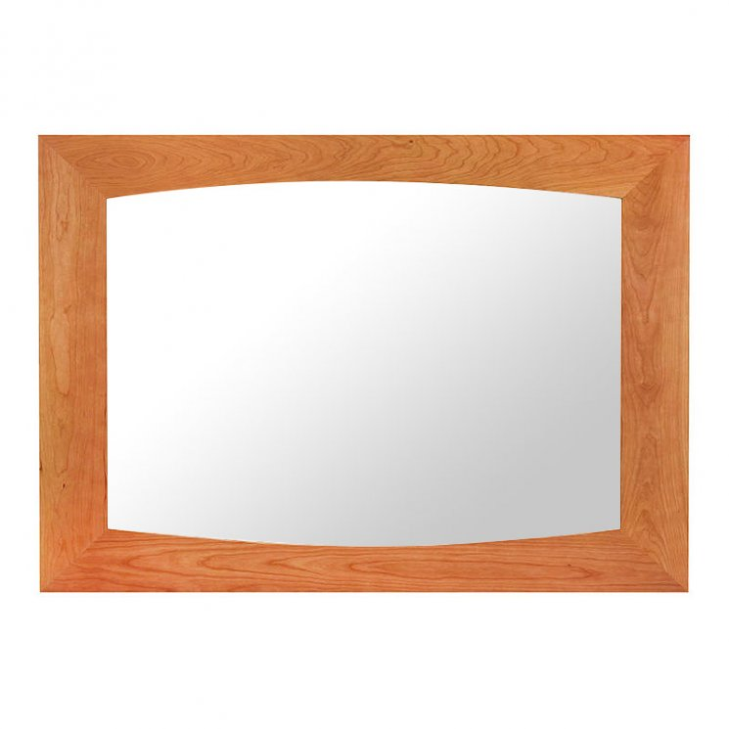

This handcrafted Natural Cherry Dresser Mirror features a beautiful arched hardwood frame and good old fashioned New England detail. Makes a great dresser mirror, or accent mirror over your sideboard or console table, for your foyer or hallway. All of our fine furniture is handcrafted in Vermont using sustainably harvested solid wood. Add a finishing touch to any room with our large Natural Cherry Dresser Mirror!